 | - To write C program to implement Unix functions

Name of Student | RONIT PATANGE | Roll No. | 9145
Sign here to indicate that you have read all relevant material provided /available on Moodle while performing and writing this experiment |  | Sign:

Late Submission Details (if any)
Reason(s) of late submission | Date of practical performance | Date of practical submission

References used
1 | Name and author of reference book(s) with page nos.
2 | Name and roll nos. of the peers whose help you have taken (if any)

Rubrics for assessment of Experiment:
Indicator | Poor | Average | Good
Timeliness  Maintains Experiment deadline (3) | Experiment not done (0) | One or More than One week late (1-2) | Maintains deadline (3)
Completeness and neatness  Complete all parts of Experiment (3) | N/A | < 80% complete (1-2) | 100% complete (3)
Originality  Extent of plagiarism (2) | Copied it from someone else (0) | At least try to implement but could not succeed (1) | Implemented (2)
Knowledge  In depth knowledge of the Experiment (2) | Unable to answer any questions (0) | Unable to answer few questions (1) | Able to answer all questions (2)

Assessment Marks:
Timeliness
Completeness and neatness
Originality
Knowledge
Total

Signature of Teacher with date

1. | Course, Subject & Experiment Details

Course & Branch | T.E. (ECS) | Estimated Time | 02 Hours Per Week
Current Semester | Semester VI | Subject Name | Linux Server Administration
Chapter No. & Unit | 2.1 | Chapter Title | Unix commands
Experiment Type | Software Performance | Subject Code | ECL 604

2. | Aim & Objective of Experiment
- To implement Unix functions using C programming
3. | Expected Outcome of Experiment
- To convert Unix commands into C program
4. | Brief Description of the experiment

- Write a C program to implement the following Unix commands:
Cat, cp, mv
(Write algorithm and code for the given question)

Cat command:

code:
#include <stdlib.h>
#include <stdio.h>
#include <unistd.h>
#include <fcntl.h>

#define BUFFER_SIZE 50

int main(int argc, char **argv)
{
int file;
char buffer[BUFFER_SIZE];
int read_size;

if (argc < 2)
{
fprintf(stderr, "Error: usage: ./cat filename\n");
return (-1);
}
file = open(argv[1], O_RDONLY);
if (file == -1)
{
fprintf(stderr, "Error: %s: file not found\n", argv[1]);
return (-1);
}
while ((read_size = read(file, buffer, BUFFER_SIZE)) > 0)
write(1, &buffer, read_size);

close(file);
return (0);
}

output:
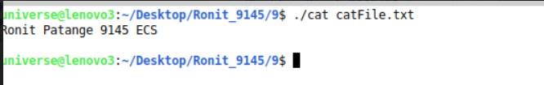

cp command:

code:

#include <stdio.h>
#include <stdlib.h>
#include <unistd.h>
#include <fcntl.h>

int main(int argc, char ** argv) {
char buffer[1024];
int files[2];
ssize_t count;

/* Check for insufficient parameters */
if (argc < 3)
return -1;
files[0] = open(argv[1], O_RDONLY);
if (files[0] == -1) /* Check if file opened */
return -1;
files[1] = open(argv[2], O_WRONLY | O_CREAT | S_IRUSR | S_IWUSR);
if (files[1] == -1) /* Check if file opened (permissions problems ...) */ {
close(files[0]);
return -1;
}

while ((count = read(files[0], buffer, sizeof(buffer))) != 0)
write(files[1], buffer, count);

return 0;
}

output:
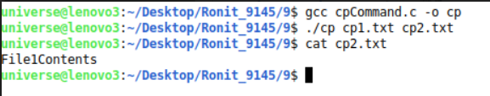

mv command:
code:

#include <stdio.h>
#include <sys/types.h>
#include <sys/stat.h>
#include <dirent.h>
#include <unistd.h>
#include <stdlib.h>
#include <string.h>

#define SBUF 256
#define DBUF 256

int main(int ac, char * argv[]) {
DIR * dir_ptr; // the directory
struct dirent * direntp;

if (ac == 1) {
printf("Usage: %s MOVE\n", argv[0]);
exit(0);
}

if (ac > 1 && ac < 3) {
printf("Error! few arguments provided ");
exit(0);
}

char src_folder[SBUF];
char dest_folder[DBUF];
strcpy(src_folder, argv[1]);
strcpy(dest_folder, argv[2]);

dir_ptr = opendir("."); //open directory
if (dir_ptr == NULL) {
perror(".");
exit(1);
}

while ((direntp = readdir(dir_ptr)) != NULL) {
if (strcmp(direntp -> d_name, dest_folder) != 0) //search file or directory
{
printf("found the file %s", dest_folder);

break;
} else
printf("not found");
break;
}
rename(src_folder, dest_folder);
closedir(dir_ptr);

return 0;
}
output:
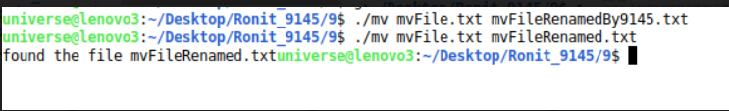

- Write a C program to redirect output of Unix command “ls -l” in some other file
code:
#include <stdio.h>
#include <unistd.h>
#include <sys/types.h>
#include <sys/wait.h>
#include <stdlib.h>

int main() {
int pid; //process id
pid = fork(); //create another process
if (pid < 0) { //fail
printf("\nFork failed\n");
exit(-1);
} else if (pid == 0) { //child
execlp("/bin/ls", "ls", "-l", NULL); //execute ls
} else { //parent
wait(NULL); //wait for child
printf("\nchild complete\n");
exit(0);
}
}

output:
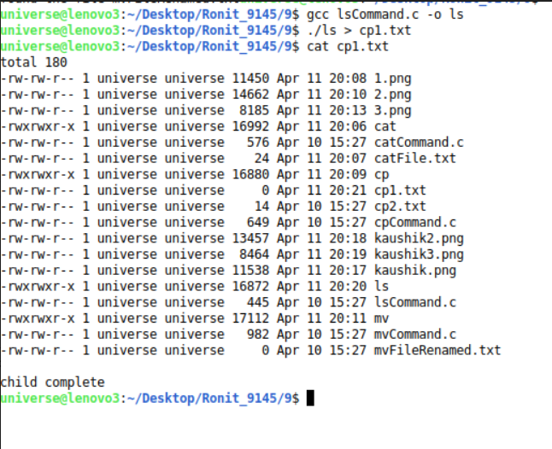

5. | Conclusions & Inferences

All questions were solved successfully and the outputs were observed.

6. | Post Lab exercise

- Write any TWO of the above programs using Java OR Python
#!/usr/bin/python
import sys, os
for _arg in sys.argv[1:]:
try:
with open(_arg, 'r') as _file:
for line in iter((_file.readline),""):
print(line),
except IOError as _err:
sys.stderr.write(os.path.basename(sys.argv[0]) + ": " + _arg +
": " + _err.strerror + "\n")
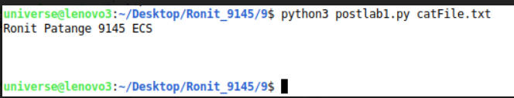

import shutil
src=r"/home/Desktop/Ronit_9145/9/post.txt"
dst_path = r"/home /Desktop/Ronit_9145/9/post2.txt" shutil.move(src, dst_path)
print("File moved to:",dst_path)
